

**ECEN 5053-003 Homework Assignment**

Course Name: Embedding Sensors and Actuators

Corresponding Module: C2M1

Week Number: 5

Module Name: AC Motor Designs

Note: Correct answer is in Blue Font

Homework is worth 100 points.

Part 1: Each question is worth 8 points.

1. An AC induction motor is rated with 4.5% slip and 3600 RPM synchronous speed Ns. What is the rotor speed Nr in RPM

Answer: 3438 RPM



1. How is the magnetic flux wave set up around the stator of an AC induction motor?

Answer: **The field windings are distributed in space 120° apart and the current in them is distributed in time (120° phase). This space and phase shift among the three windings produce a rotating magnetic field.**

A three-phase induction motor consists of three phase winding as its stationary part called stator. The three-phase stator winding is connected in star or delta. The three phase windings are displaced from each other by 120°. The windings are supplied by a balanced three phase ac supply.

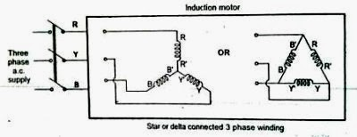

The three phase currents flow simultaneously through the windings and are displaced from each other by 120° electrical. Each alternating phase current produces its own flux which is sinusoidal. So, all three fluxes are sinusoidal and are separated from each other by 120.

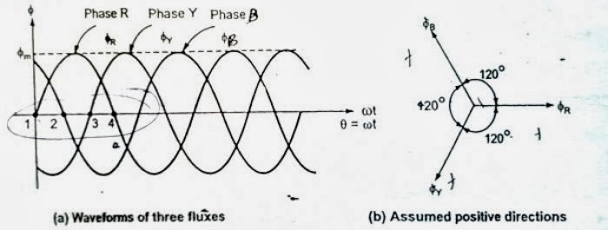

Therefore, the resultant magnetic field is such that its poles do not remain in a fixed position on the stator but go on shifting their positions around the stator. For this reason, it is called a rotating field [**[1]**](http://www.studyelectrical.com/2014/01/production-of-rotating-magnetic-field.html) .

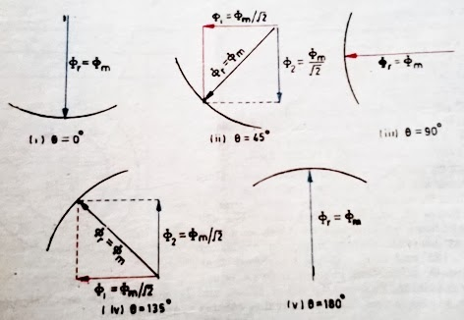

1. What is the difference between locked rotor torque and breakdown torque in an AC motor?

Answer: The **Locked Rotor Torque** is also known as **Starting Torque**. **It is the torque an electrical motor develops when starting at zero speed**. This torque in high amounts is required for applications or machines which are hard to start – for example heavy duty cranes. A lower Locked Rotor / Starting Torque can be accepted for centrifugal fans or pumps where the start load is low or close to zero. Locked rotor essentially refers to the situation of the motor when it is powered off, and the shaft is stationary.

However, the **Break-down Torque** is the **highest torque available before the torque decreases when the machine continues to accelerate to working conditions**. This is an important quantity since it implies that operating the AC induction motor at full load will not result in maximum torque. However, maximum torque is obtained a point before reaching to the full load condition [**[2]**](https://www.engineeringtoolbox.com/electrical-motors-torques-d_651.html) .

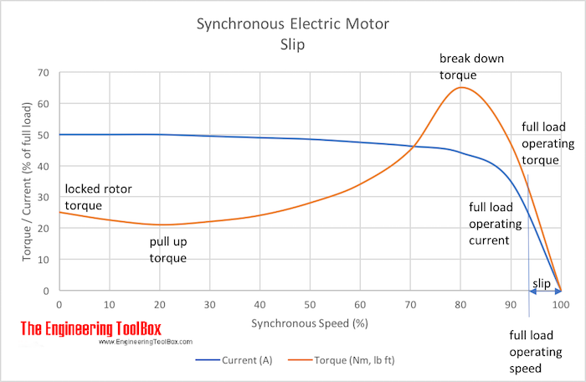

D. Why is the torque in an AC motor proportional to the slip?

Answer: The slip is necessary for the torque generation. It is so because if the rotor rotates at the synchronous speed (rotating speed of the magnetic field) then the metal bars of the rotor cage won’t cut this flux, and therefore the field won’t be able to move the rotor at all! So the actual speed of rotation is always somewhat lesser than the synchronous speed, and this difference is called slip.

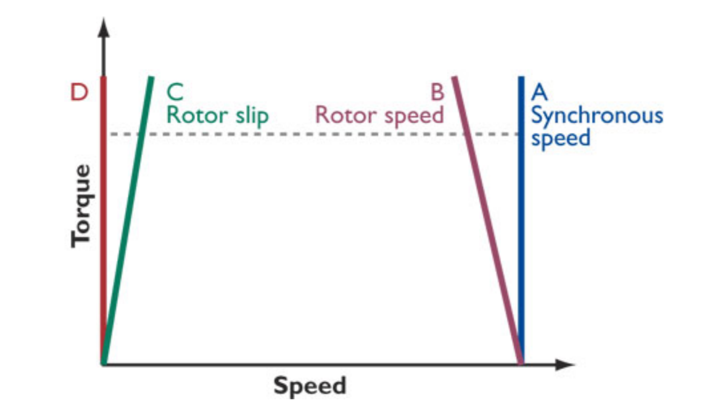

As the **slip increases**, or in other words, as the speed of rotor decreases, the **amount of magnetic force field that is being cut by the metal bars – increases**, and this directly results in the higher energy conversion ratio – therefore, the torque is important in AC motor is proportional to the slip [**[3]**](http://www.powermation.com/eng_lib/ac_induction_motor_slip.pdf) .

1. Refer to this NEMA curve below for types A, B, C, and D motors.

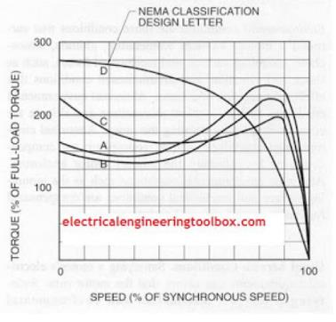

E.1 Which of the types of motors has the highest locked rotor torque?

Answer: Locked rotor torque is the value of torque given at 0% of speed, therefore **D type** motors have highest locked rotor torque, followed by C type, A type, and B type.

E.2 Other than for type D, which of these motors has the lowest breakdown torque?

Answer: Looking at the curves, it is evident that the **C type** motors have the lowest breakdown torque, as the their curve leads to the lowest point among all – when the increase in speed decreases the resultant torque.

E.3 Other than for type D, which of these motors has the highest pullup torque?

Answer: Pull up torque is defined as the torque that is being generated once the motor has started running. Looking at the graph, while aboiding D type curve, **C type** curve attains the highest value at its own minimum point, after locked rotor torque point and before breakdown torque point.

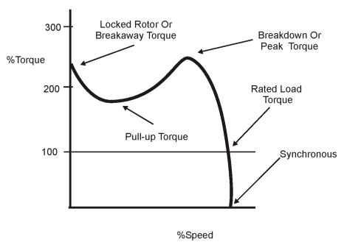

E.4 Which one of these motors would you use if you needed to accelerate an enormous load from zero speed to a high speed in as short a time as possible?

Answer: Since I have an enormous load at stationary condition, and the acceleration is very high (from zero speed to high speed, thus large Δvelocity, and in short time thus small Δtime), I would go with **D type** motor. This is perfect for the application as it has enormous locked rotor torque, which is certainly a necessity in this application. Besides, the torque doesn’t drop much till 70% of Synchronous speed – which is not a low speed by any means. Other motors are providing somewhat more torque at around 10% of higher speed, but high torque is not required when the load is already in motion.

E.5 What would happen to the torque-speed curve for all of these motors if you purposely powered them with AC current at a voltage well under the rated voltage for the motors.

Answer: If the **supply voltage is quite lower** than the rated voltage, then the AC motor will simply **burn out** because, as Power = Voltage * Current, decrease in voltage will cause motor to pull more current, and after a limit, that will burn the copper windings. However, if the **supply voltage is not sufficiently lower enough to cause this** – then simple the torque ratings would decrease drastically. In that case, I think that **the shape of the curves would be retain more or less, however, the values on Y axis would plummet – indicating a giant loss in the efficiency and the resultant torque**.

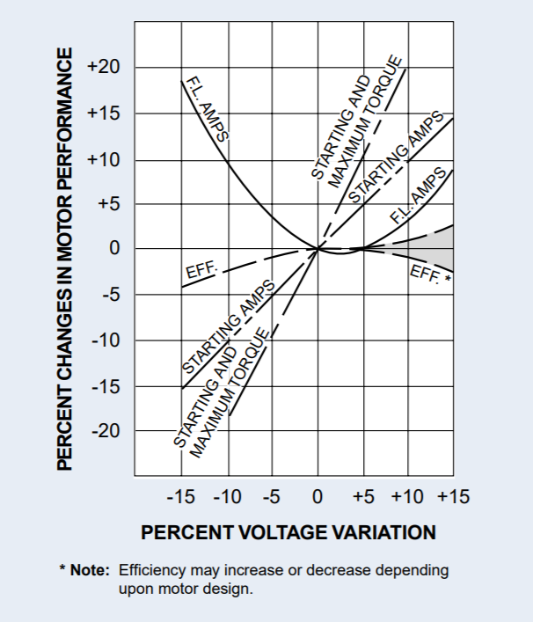

References [**[4]**](https://www.engineeringtoolbox.com/electrical-motors-torques-d_651.html)[**[5]**](https://qph.fs.quoracdn.net/main-qimg-2ec858c9fd1d41a071fdbfd49e25e12e-c)[**[6]**](http://www.burfordphotos.com/EASA%20articles/effects%20of%20high%20or%20low%20voltage.pdf)

1. Refer to these diagrams below of a 3-phase AC motor.

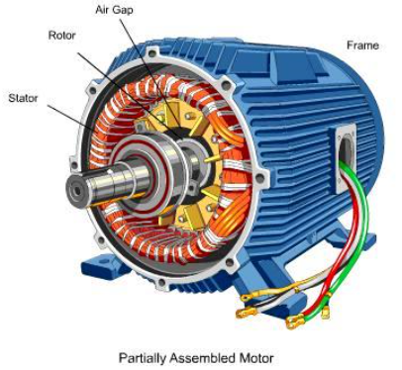

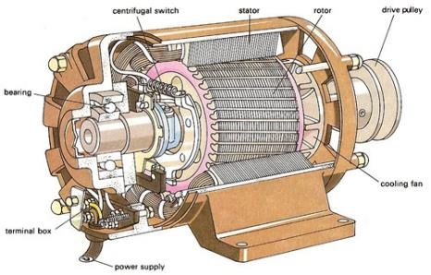

F.1 What is the function of the stator? Describe its construction.

Answer: The primary function of the stator is **to produce a rotating magnetic field** in the AC Motor. For this, a three-phase power supply is used to energize the for the stator coils. But this is not enough, as for the resultant magnetic field to rotate in space, a special construction is required of the stator coils winding. Below is the figure of the connection for a 6-pole stator.

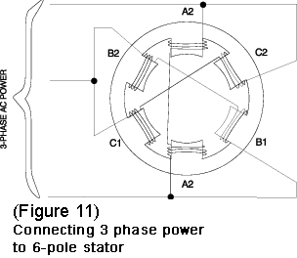

Each phase of the three-phase power supply is connected to opposite poles and the associated coils are wound in the same direction. The polarity of the poles of an electro-magnet is determined by the direction of the current flow through the coil. Therefore, if two opposite stator electro-magnets are wound in the same direction, the polarity of the facing poles must be opposite. When pole A1 is N, pole A2 is S and when pole B1 is N, B2 is S and so forth [**[7]**](https://www.galco.com/comp/prod/moto-ac.htm) .

.

F.2 What is the function of the rotor? Describe its construction.

Answer: The primary function of the rotor is **to use the rotating magnetic field via induction, to create useful and operation torque, that can be taken out using shaft connected to the rotor**. Rotor consists of a cylindrical laminated core with parallel slots for carrying the rotor conductors, which are thick, heavy bars of copper or aluminum or its alloys. The conductor bars are inserted from one end of the rotor and as one bar in each slot. There are end rings which are welded or electrically braced or even bolted at both ends of the rotor, thus maintaining electrical continuity [**[8]**](https://www.brighthubengineering.com/diy-electronics-devices/43723-how-are-squirrel-cage-induction-motors-constructed/) .

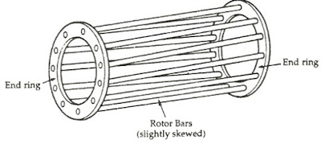

Notably, the end rings and the rotor conducting bars are permanently short-circuited, thus it is not possible to add any external resistance in series with the rotor circuit for starting purpose. The rotor conducting bars are usually not parallel to the shaft, but are purposely given slight skew. There are some very important functionalities achieved by this arrangement, such as the successful avoidance of ‘cogging’ effect (the tendency of rotor teeth remaining under the stator teeth due to the direct magnetic attraction between the two), reduced magnetic hum, increased rotor resistance (due to comparatively lengthier rotor conductor bars), to avoid ‘crawling’ (a phenomenon where harmonic components introduces oscillations in torque), increased slip etc [**[9]**](https://electricalbaba.com/why-skewed-rotor-conductors-in-an-induction-motor/) .

F.3 Why is the air gap between the stator and rotor made so small, roughly .020” (0.5 mm)?

Answer: For the magnetic flux to get linked to rotor from stator effectively, smaller air gap is desired. This is because both - stator and rotor are made up of magnetic material and therefore having more permeability and hence less reactance. However, air has high reactance and therefore **increased air gap leads to increased reactance of the motor, and lower power factor - as more flux is leaked and the power is lost**. Thus for higher performance, smaller air gap is desired [**[10]**](https://people.ucalgary.ca/~aknigh/electrical_machines/fundamentals/f_dc_simple.html)[**[11]**](http://www.marineengineering.org.uk/page55.html) .

1. Refer to this diagram below for a synchronous AC motor.

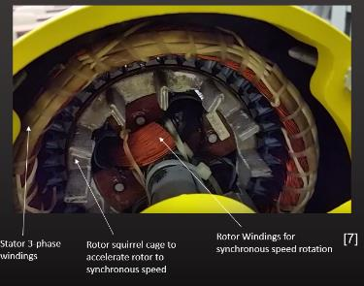

G.1 At what speed does the synchronous AC motor rotate and how do you calculate this speed?

Answer: A synchronous AC motor is a type of motors which have their rotational speeds synchronized with the power supply frequency. In the figure, a 3-phase stator winding is shown therefore, synchronous speed **S = (120 * f) / n**. Here: S = rotor speed in rpm, f = AC line frequency, and n = number of poles per phase [**[12]**](https://www.allaboutcircuits.com/textbook/alternating-current/chpt-13/synchronous-motors/) .

G.2 What are two reasons you would use an AC synchronous motor in an application?

Answer: Synchronous motors generally have **higher efficiency** when compared to induction motors, and therefore are preferable to use in conditions where loads require constant speeds. Also, since these motors have a strong correlation between rotational speed and supply voltage frequency, they are **very precise** while used in multitude of applications requiring reliable speed and/or position control. Other than this, they can be used to **improve power factor** as well [**[13]**](http://electricalquestionsguide.blogspot.com/2012/09/applications-synchronous-motors.html) .

1. Refer to this cut-away photo of a single-phase AC motor.

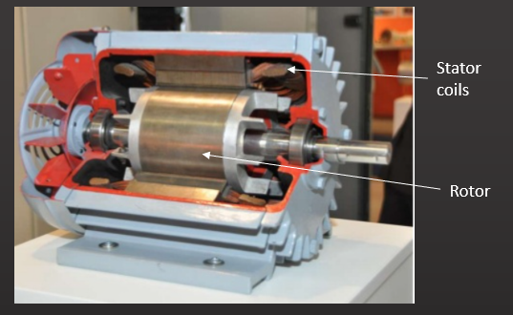

H.1 How do the stator coils create a fluctuating magnetic field?

Answer: The stator coils are energized with a single phased AC voltage source. Now the magnetic field that is generated due to the flow of electric current in an inductor, is dependent on the flow direction of that current [**[14]**](http://hyperphysics.phy-astr.gsu.edu/hbase/magnetic/magcur.html). **Since the coils are powered up with Alternating Current – which essentially changes its flow direction a number of times in a second, the generated magnetic field is also changed accordingly**. Therefore, a fluctuating magnetic field is formed.

H.2 Why does a single-phase AC motor need a mechanism to create a net torque on the rotor during startup?

Answer: The single coil of a single-phase induction motor does **not** produce a **rotating magnetic field**, but **a pulsating field** reaching maximum intensity at 0° and 180° electrical.

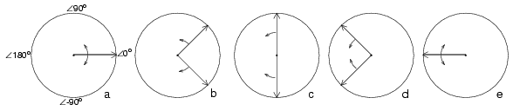

Another view is that the single coil excited by a single-phase current produces two counter rotating magnetic field phasors, coinciding twice per revolution at 0° (Figure above-a) and 180° (figure e). When the phasors rotate to 90° and -90° they cancel in figure b. At 45° and -45° (figure c) they are partially additive along the +x axis and cancel along the y axis. An analogous situation exists in figure d. The sum of these two phasors is a phasor stationary in space, but alternating polarity in time. Thus, no starting torque is developed [**[15]**](https://www.allaboutcircuits.com/textbook/alternating-current/chpt-13/single-phase-induction-motors/) . In simpler terms, **at the start when the rotor is stationary, the two rotating magnetic fields are opposite, producing an equal and opposite torque – therefore making the total torque on the rotor zero**. Thus, single phase AC motors require some mechanism to provide a starting torque [**[16]**](https://www.top-ee.com/working-principle-of-single-phase-induction-motor/) .

H.3 How is the net torque created in a single phase AC motor?

Answer: As per the analysis of single phase AC motor, it can’t provide starting torque however, once the rotor is started revolving – it will keep on rotating. The starting net torque can be created by building a 2-phase motor, deriving 2-phase power from single phase. This requires a motor with two windings spaced apart 90o electrical, fed with two phases of current displaced 90o in time. This is called a permanent-split capacitor motor.

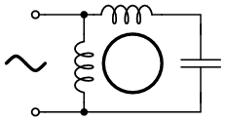

**This will result in auxiliary winding producing two oppositely revolving magnetic fields, one of which – will cancel the RMF of the main winding and the other one will be added up to that of the main winding – effectively producing a single magnetic field revolving under a specific speed. This final single magnetic field will give the rotor starting torque** [**[17]**](https://www.allaboutcircuits.com/textbook/alternating-current/chpt-13/single-phase-induction-motors/)[**[18]**](https://www.top-ee.com/working-principle-of-single-phase-induction-motor/).

1. Refer to these diagrams below of a split phase motor used in a clothing dryer.

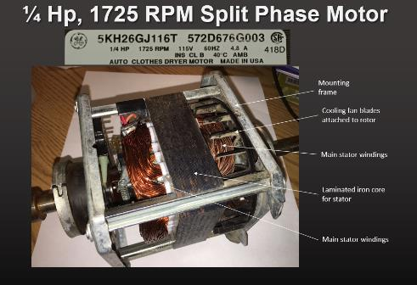

Centrifugal switch

switch

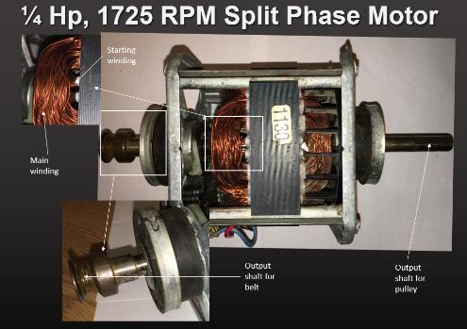

I.1 Describe the differences in dimensional and electrical properties between the main and starting windings. Why are these windings different?

Answer: The principle behind the operation of split phase motor is that the **current’s phase shift is dependent on dimensional and electrical properties of the coil/winding of a conductor**. Therefore, if a secondary/starting winding with different physical and electrical properties is used, then the current flowing through it will be experiencing different phase shift than that of main winding. To exploit this, an auxiliary winding is used which is specifically made to have **lower inductance, and higher resistance** – than that of main winding. Generally, to achieve these properties, **starting winding is made up with much fewer turns of smaller/thinner wire**. By placing both windings at 90° of each other, it is possible to have a phase difference of up to 30°. This results in a moderate starting torque, later to be disconnected by a centrifugal switch [**[19]**](https://www.allaboutcircuits.com/textbook/alternating-current/chpt-13/single-phase-induction-motors/).

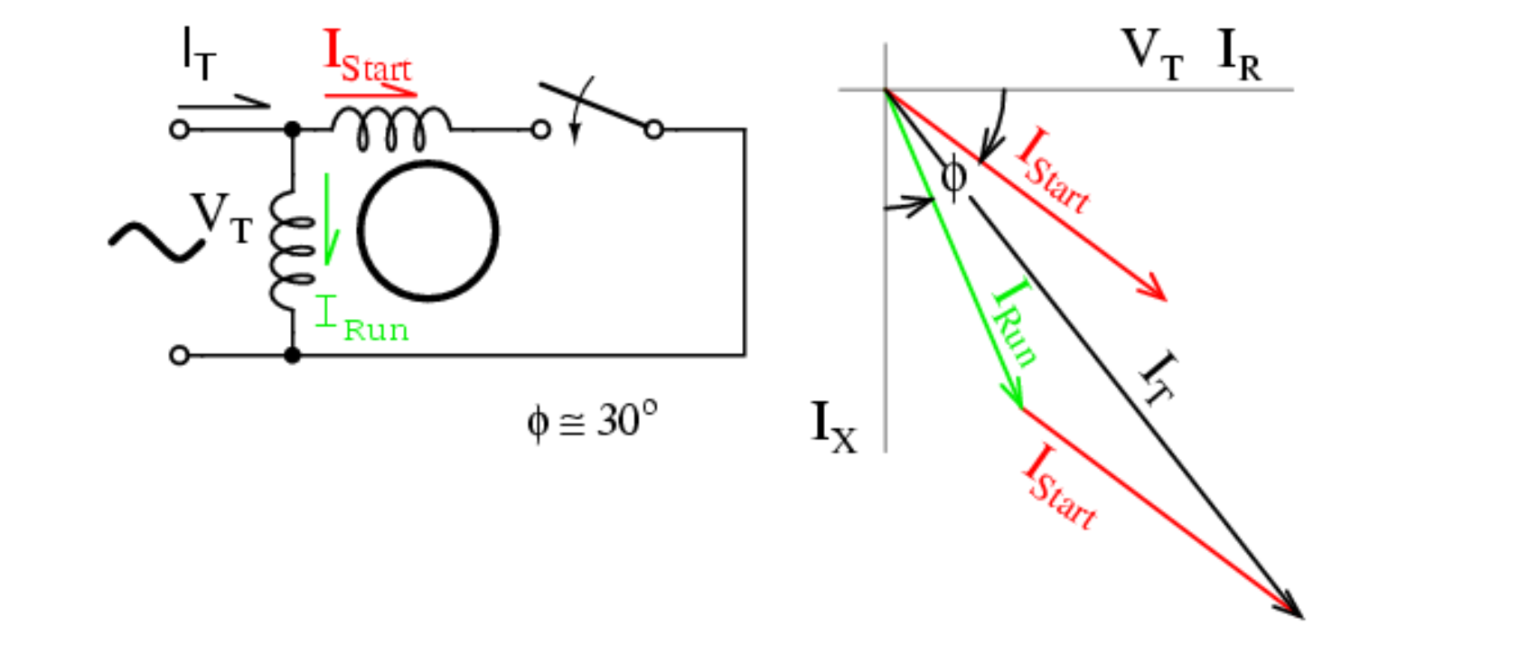

I.2 What is the function of the laminated iron core?

Answer: In any device which is using induction for functioning, Eddy currents will be formed inside it. This currents are generated due to the induced EMF, which is always present in such devices. Eddy currents are the result of the rotor rotating in a magnetic field. They are a form of magnetic loss, and the power loss due to the flow of eddy currents is referred to as eddy current loss. This can be very significant if not reduced, and therefore – to break electrical connection and limit the eddy currents to a greatly reduced area, laminated iron core is used. This will prevent eddy currents from accessing a large electrical area, and therefore they will only have a small emf to reply upon for their generation. This also reduces heating, another effect of large eddy currents [**[20]**](https://www.springer.com/cda/content/document/cda_downloaddocument/9789811006234-c2.pdf?SGWID=0-0-45-1556383-p179850321) .

I.3 What is the function of the centrifugal switch?

Answer: The function of centrifugal switch is **to disconnect the starting winding, once the motor reaches a specific speed**, as it is no longer needed [**[21]**](https://www.allaboutcircuits.com/textbook/alternating-current/chpt-13/single-phase-induction-motors/) .

I.4 How does the centrifugal switch work?

Answer: A split-phase AC motor has a centrifugal switch inside its case, attached to the motor shaft. The switch is closed when the motor is off and motionless. When the motor is turned on, the switch conducts electricity to auxiliary/starting winding in the motor, providing starting torque. As the motor's revolutions per minute increase, the switch opens, as the motor no longer needs the boost. **The switch has a mechanism which responds to centrifugal force, pulling against it. When the motor reaches a specific speed, the centrifugal force becomes powerful enough to open the switch and break the electrical connection. When the motor stops, a spring pulls the switch mechanism closed again**. A set of calibrated weights on the centrifugal switch determine the speed at which the switch opens. A greater mass pulls with more force against the spring, opening the switch at lower revolutions per minute. A smaller mass requires the motor to spin faster for the centrifugal force to counteract the spring [**[22]**](https://sciencing.com/centrifugal-switches-work-12135546.html) .

1. Refer to this circuit diagram below of a permanent split capacitor (PSC) motor.

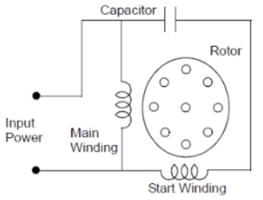

J.1 What are the four advantages of using a permanent split capacitor (PSC) motor?

Answer: Advantages

1. In the permanent split capacitor motors, there is no need to provide a centrifugal switch.
2. The efficiency of this motor is high, this is resulting from the fact that the power factor is high – because the capacitor is connected permanently in the circuit.
3. This motor has a higher pullout torque [**[23]**](https://circuitglobe.com/permanent-split-capacitor-psc-motor.html) .
4. The direction of the motor can be easily reversed by switching the capacitor in series with another winding.
5. This motor can also be configured to be used as a servo motor [**[24]**](https://www.allaboutcircuits.com/textbook/alternating-current/chpt-13/single-phase-induction-motors/) .

J.2 What is the major disadvantage of using a permanent split capacitor motor?

Answer: Disadvantages

1. Paper capacitor has to be used as Electrolytic capacitor can’t be used for continuous running. Paper capacitors are quite higher in cost, while also having much larger size.
2. It has quite low starting torque, which is even lower than the full load torque [**[25]**](https://circuitglobe.com/permanent-split-capacitor-psc-motor.html) .
3. This type of motor suffers increased current magnitude and backward time shift as the motor comes up to speed [**[26]**](https://www.allaboutcircuits.com/textbook/alternating-current/chpt-13/single-phase-induction-motors/) .

1. Refer to this photo below of a shaded pole motor.

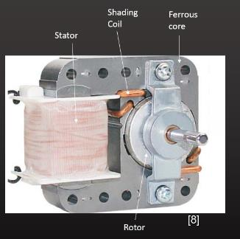

K.1 What are the three advantages of using a shaded pole motor?

Answer: Advantages

1. Shaded pole motors are very low priced, while also being highly reliable. These qualities enable many applications to be developed while also rendering them affordable to the masses.
2. Construction is quite easy, compared to many other single-phase AC motors.
3. These motors are particularly rugged in nature and therefore, can be used in harsh environments [**[27]**](https://www.papersbureau.com/advantages-disadvantages-shaded-pole-motor/) .

K.2 What are the three disadvantages of using a shaded pole motor?

Answer: Disadvantages

1. Efficiency is quite low. Thus, these motors are incompetent.
2. The starting torque of shaded pole motors are observed to be low. Therefore, the applications are limited.
3. Copper loss is quite high, since the shading is made up of Copper as the base material [**[28]**](https://www.papersbureau.com/advantages-disadvantages-shaded-pole-motor/) .
4. What are the applications for a universal motor, and why is this type of motor well suited for these applications?

Answer: There are many applications for universal motor, thanks to its specific **characteristics** such as **high starting torque, very high speed at no load, easiness in controlling the speed, lightweight and compactness** etc. Due to this, they’re used in **portable drilling machines, hair dryers, food processors, table fans, blowers, polishers, vacuum cleaners, domestic sewing machine** etc [**[29]**](https://circuitglobe.com/universal-motor.html)[**[30]**](https://www.electricaleasy.com/2014/02/universal-motor-construction-working.html) .

1. Refer to this screen shot of a universal motor from our video on Universal and gear motors (C1M1V8.mp4 stored in Canvas Pages section)

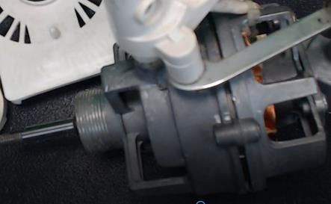

M.1 Describe the construction of the stator. Provide a screen shot of the stator and document its components.

Answer: The construction of universal motor’s stator is quite simple. It is made up of a **laminated and magnetized iron core**, and two field coils (**main field winding** and **compensation winding**). These field coils are wounded on field poles, which are mounted on the stator. This arrangement is shown below:

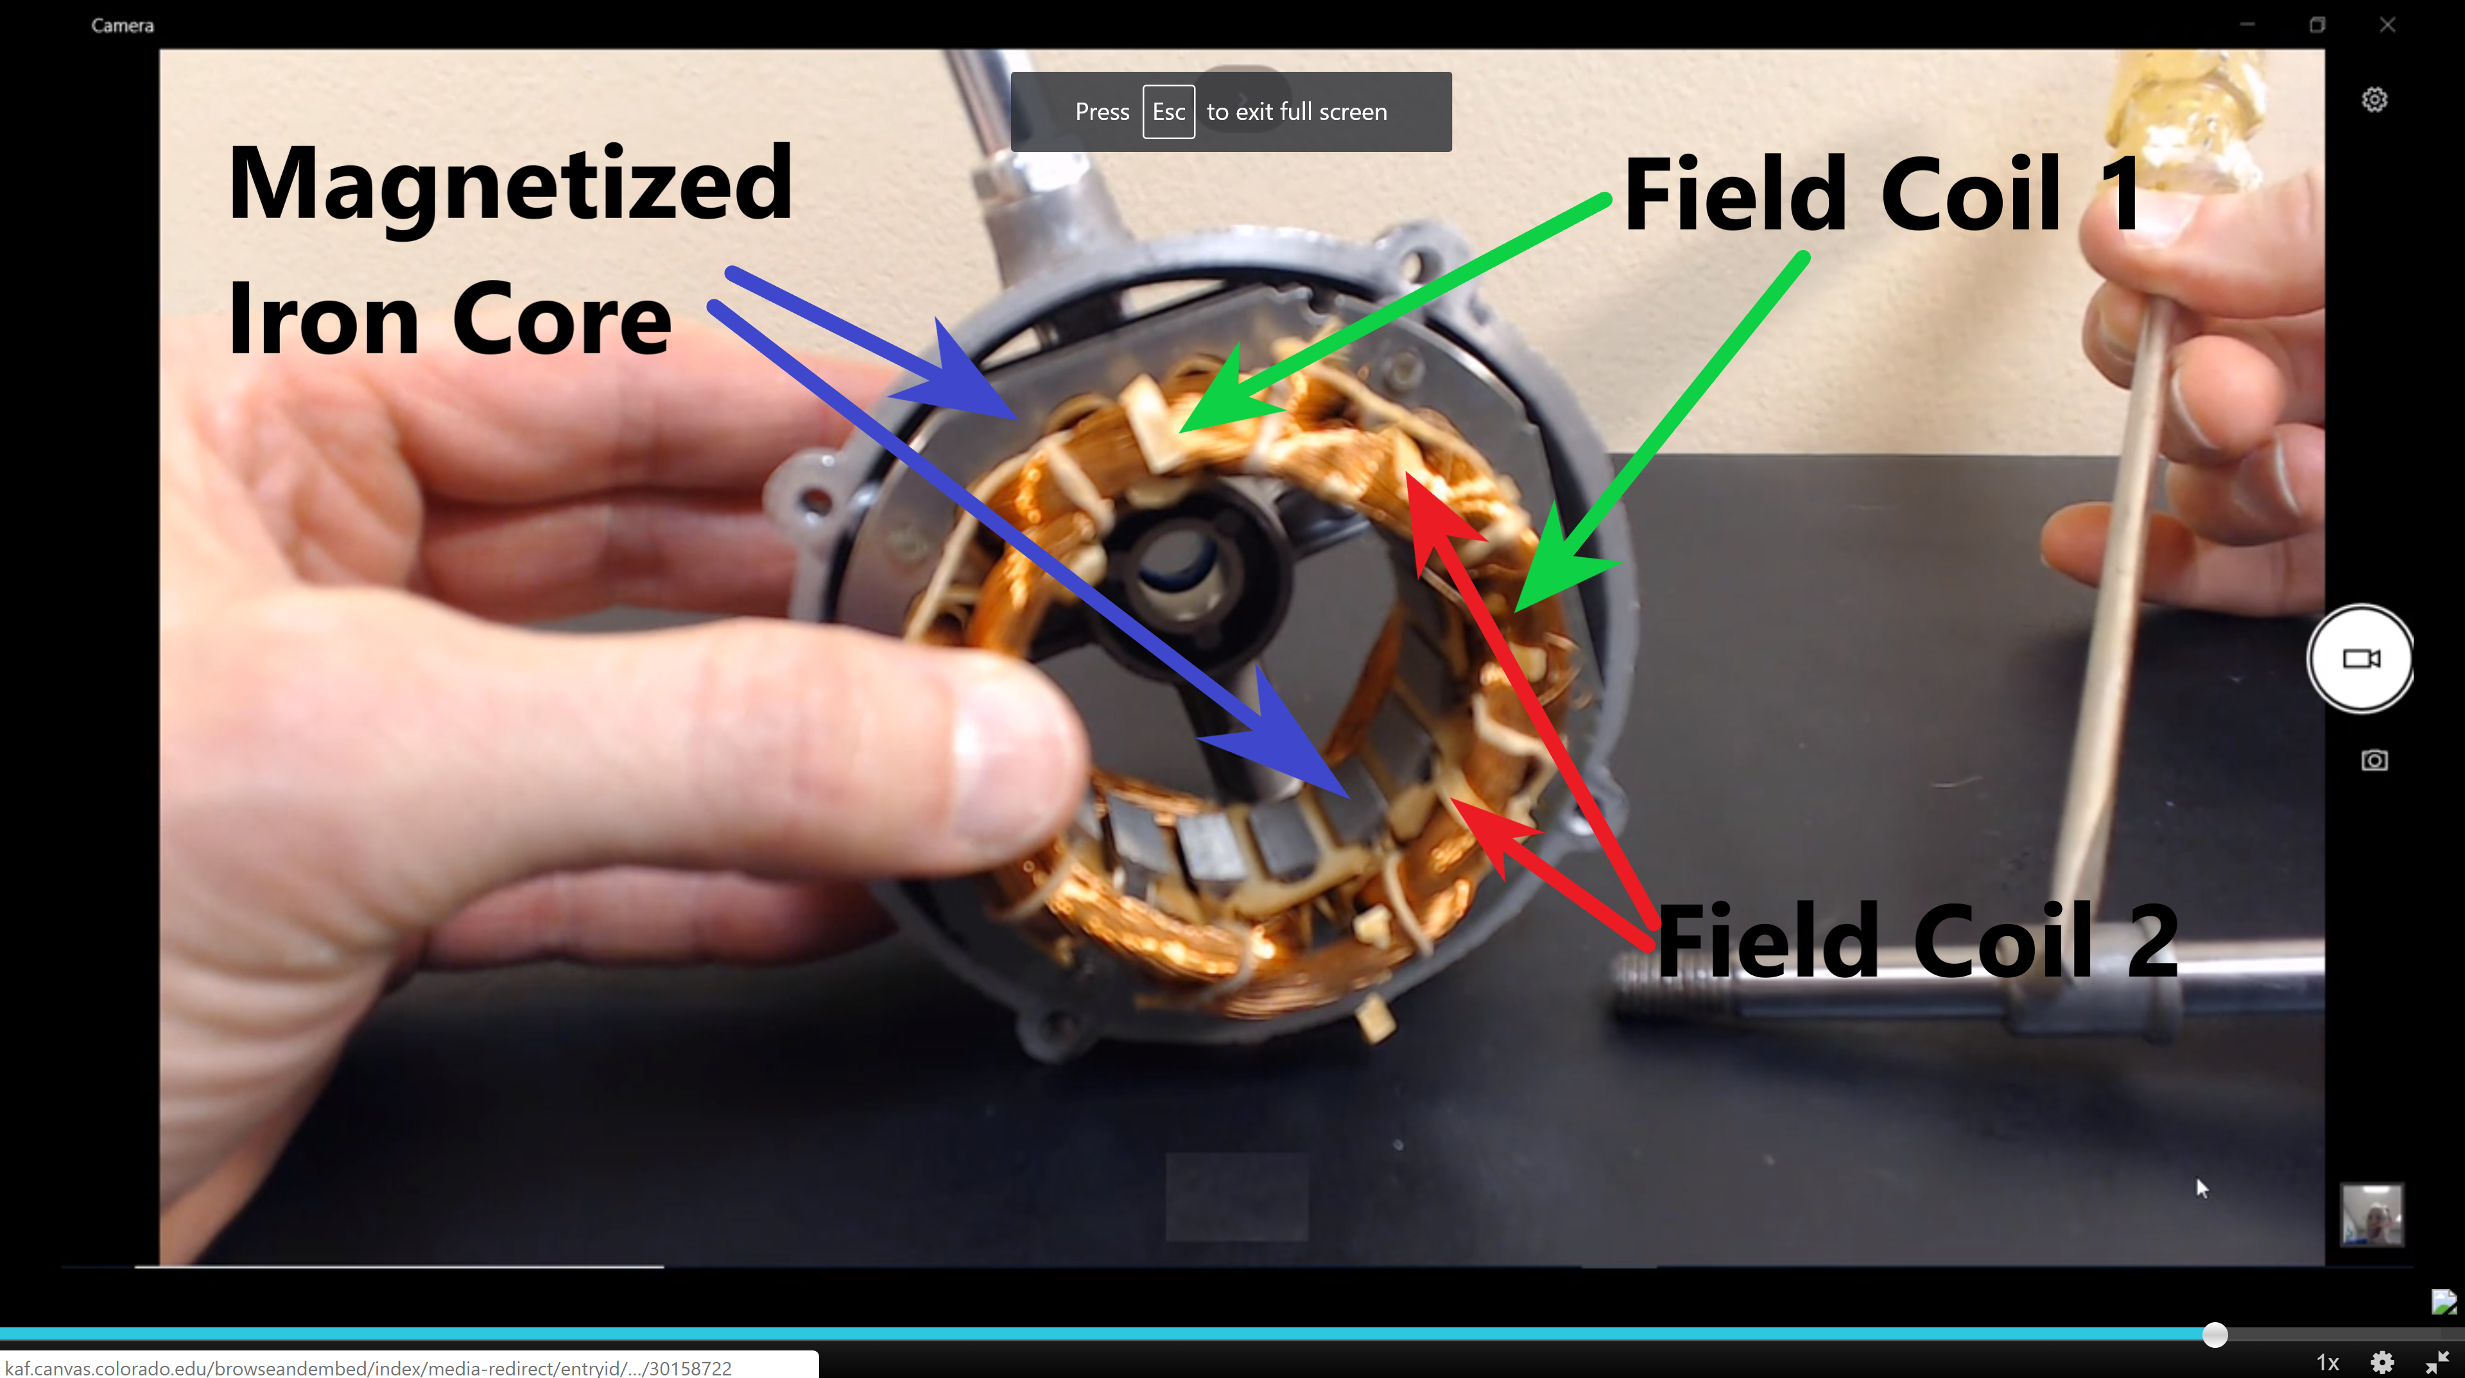

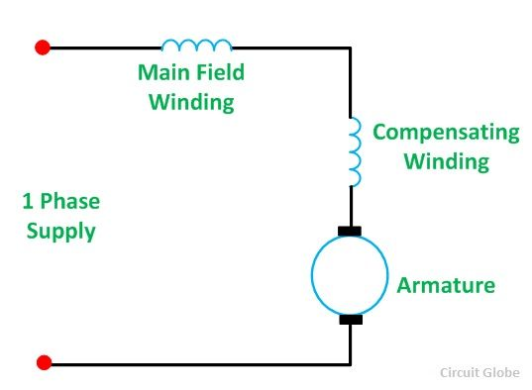

M.2 What would happen to the speed of the fan if the armature were to touch the iron core of the stator during rotation?

Answer: If the rotor touches the stator during the rotation, then **mechanical friction would take place, slowing down the armature/rotor – in turn reducing the effective speed of the motor by a significant amount**.